NGO COMMITTEE ON FINANCING FOR DEVELOPMENT
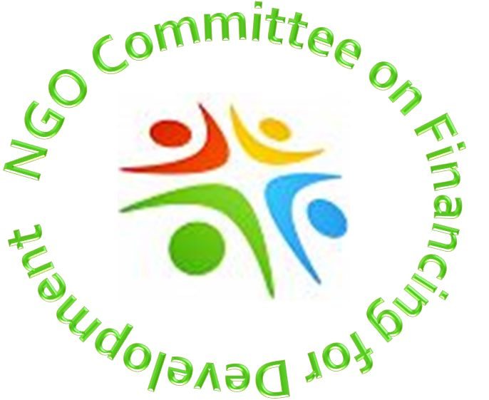
December 2014

PUTTING PEOPLE AND PLANET FIRST:
FINANCING SUSTAINABLE DEVELOPMENT REQUIRES POLITICAL COURAGE
The many crises our world and peoples face are clear evidence that international budget decision-making and financial systems favor the few to the detriment of the masses, and favor unjust private profits over the health of the planet. Despite significant efforts by the global community to implement the Millennium Development Goals, vast numbers of people still live in poverty, ever-smaller numbers accumulate outrageous wealth, and indiscriminate growth and consumption destroy the earth.
The world has the money and expertise to solve these problems, but we have to allocate them better. The problem is not in having enough money; it is in having enough political courage. Sustainable development is an economic and ethical issue. Pouring funds into weapons instead of medicines and schools is an ill-advised choice that must be challenged. There is no justifiable reason that annual global spending on war and violence should be 600 times greater than spending on peace and social progress, as United Nations Secretary General Ban Ki-moon calculates.
We can change budget priorities by changing political will. Civil Society, with its grassroots perspective, is uniquely situated to articulate the moral imperatives of reducing inequalities and keeping our planet healthy, and thus must be heard. Civil Society experiences in developing regions must be shared and people living on the margins must have a strong voice in global economic planning. Civil Society has valuable insight on means of implementation that policy-makers would be wise to seek out.
Update and reform of the global financial architecture has been on the development agenda for decades, but very little has changed. This is an example of misplaced priorities. It is time for people and the planet to benefit from global financial systems that are transparent, participatory, fair, inclusive, and safe from collapse. The United Nations must be at the center of the reform process. Developing countries have more input and influence at the UN than in other economic forums like the G20, the World Bank, the IMF and the Paris Club. Balance is crucial for credibility.
Balance is also crucial in public/private partnerships if they are to be a major source of financing for sustainable development post-2015. A multi-faceted approach to meeting needs is worth exploring with caution. How we finance determines what we finance. Long-term public projects cannot be forgotten in a rush for corporate gains. Privatization of profits but socialization of losses cannot be tolerated.
THEREFORE, THE NGO COMMITTEE ON FINANCING FOR DEVELOPMENT URGENTLY CALLS FOR:
- Putting the needs of people and the planet at the heart of all global economic efforts;
- Recognizing that financing for sustainable development is a moral as well as an economic issue;
- Building political will for reallocation of resources to address sustainable development priorities;
- Equal representation and voice of developing countries at all economic forums;
- Reforming international financial institutions and systems through the UN;
- A human rights framework governing international financing, taxing, trade, and business;
- Monitoring, transparency, and accountability for all stakeholders.

