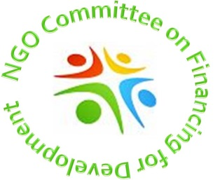
NGO COMMITTEE ON FINANCING FOR DEVELOPMENT
www.ngosonffd.org

2018-2019

FOR COMMITTEE RECORDS

Name of organization ___________________________________________________________

Name of representative __________________________________________________________

E-mail of representative __________________________________________________________

MEMBER CONTRIBUTION TO COMMITTEE

Members have agreed to contribute $25.00 annually to support the work of the committee.

Please pay in cash or with a check payable to: NGO Committee on Financing for Development

In the memo line, please indicate: NGO FfD dues

Contribution can be given to the treasurer at the time of the committee meeting. If you would like to mail your check, please contact the treasurer, Lyn Hensle-Hirsch, at her email: mhenslehirsch@gmail.com

- - - - - - - - - - - - - - - - - - - - - - - - - - - - - - - - - - - - - - - - - - - - - - - - - - - - - - - - - - - - - - - - - - -

FOR OFFICE USE ONLY

Received: DATE: ____/_____/_________

The sum of $____________ (Check #___________) or (Cash _____)

Signed _____________________________________, Treasurer of the NGO Committee on FfD
Lyn Hensle-Hirsch

