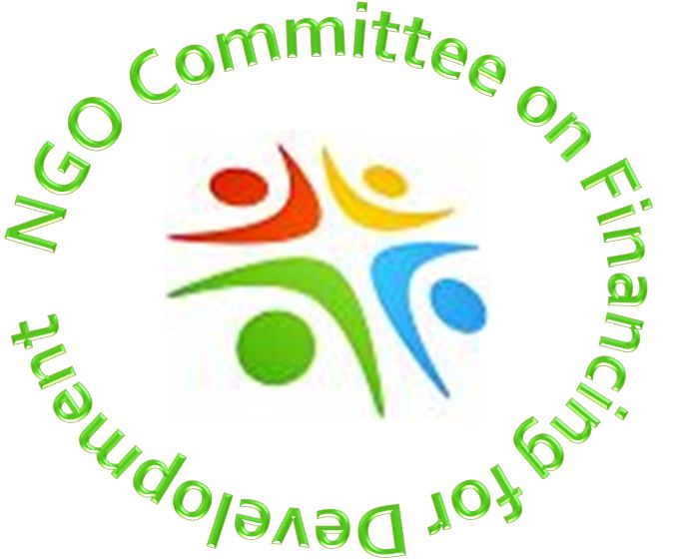

NGO COMMITTEE ON FINANCING FOR DEVELOPMENT
ANNUAL REPORT
JUNE 2015 – JUNE 2016

GENERAL CONSIDERATIONS

- AT AND WITH THE UNITED NATIONS (UN) - Our committee works closely with many United Nations bodies, but most especially with the Economic and Social Council (ECOSOC), the Financing for Development Office (FfDO), and with the Non-Government Liaison Service (NGLS).

- CoNGO - Our committee has been a member of “The Conference of Non-Governmental Organizations in Consultative Relationship with the United Nations” (CoNGO) since it was founded.

- Our committee brochure has given us the opportunity to make us better known amongst other NGO committees, especially in the area of development and financing, as well as with UN agencies and UN Member States.

- Our committee website is http://www.ngosonffd.org/ and contact can be made through dlkomifi@yahoo.com ,
FFDChair@ngsonffd.org or secretary@ngosonffd.org

- A calendar of events was prepared at the beginning of the current year of activity. However, due to frequent changes and additions to UN meetings, especially relating to the follow-up to the “Post 2015 Sustainable Development” and “2030 Agenda” processes and the follow-up to the 3rd Financing for Development Conference held in Addis Ababa in July 2015 (which includes follow-up to Monterrey [2002] and Doha [2008]), the calendar has had to be modified and updated frequently.

- GSEG and ACG - Our committee is a founding member of the “Global Social Economy Group” (GSEG) and as such works with financing for development related NGOs large and small from around the world. There are currently more than 800 member organizations and 995 individuals along with others still wishing to join these efforts. Participating organizations include movements, networks, federations and coalitions among various constituencies (both those formally recognised within the current structure of the Major Groups, such as NGOs, Women, Children and Youth, and Trade Unions, but also people living with disabilities, aging and others) as well as regional and thematic groupings. In order to facilitate coordination, an Addis Ababa Civil Society Coordinating Group (ACG) was formed, composed of 21 representatives of GSEG member organizations. It was decided that the ACG should continue to lead in the Addis Ababa follow-up processes. A Rapid Response Group (RRG) has also been set up. Our committee chair is one of the 21. Most of the Group’s preparations are advanced by subgroups corresponding to the FfD thematic pillars or by designated task teams created for a specific occasion (i.e. drafting team, communication team). Further informationcan be found at https://csoforffd.wordpress.com/

- COORDINATING EFFORTS - Our committee has coordinated to a greater extent than in years past with the major groups of the sustainable development and post 2015 process. We have co-sponsored a number of initiatives with the NGO Committee on Social Development in recognition of the synergistic relationship between social development and financing for development. The two committees intend to continue this collaboration with each other and will report on the work accomplished and planned at each others’ committee meetings. Similar efforts are being considered with other development oriented NGOs working at the UN.

MEMBERSHIP STRUCTURE

- MEMBERSHIP - The NGO Committee on Financing for Development recognizes two levels of membership: “Full” (dues paying) and “Associate”. We currently have 30 full member organizations and 26 associate organizations. The last few months have seen an increase of participation and effort.

- EXECUTIVE COMMITTEE
  - Chair Daniel LeBlanc
  - Vice Chair Cheryl Morrissey
  - Secretary Veronica Brand
  - Treasurer Jean Stoner
  - Member-at-large Teresa Kotturan
  - Member-at-large Marc Jourdan

- EXECUTIVE COMMITTEE RETREAT was held August 14th 2015. Part of the process was to review the 2014-2015 year. At our July committee meeting time was taken to work in small groups to give members an opportunity to highlight good practices and what was appreciated in the work and processes during the year as well as to indicate what should be continued and what might be good to initiate. Members were invited to send an email to executive committee members before August 14th and comment on “what has worked well; what could be improved”. The other part of the process was to prepare for the coming year.

- EXECUTIVE COMMITTEE MEETINGS have been held monthly, usually two weeks after the regular committee meeting.

- COMMITTEE MEETINGS have been held monthly, the first Wednesday of each month, from 2:00 to 4:00 p.m.

- FINANCING FOR DEVELOPMENT OFFICE (FfDO) AND THE NON-GOVERNMENT LIAISON SERVICE (NGLS) – Mr. Daniel Platz of the FfDO (Economics Affairs Officer, Multi-stakeholder and Outreach Branch) has come regularly to our committee meetings to give us updates and keep us informed. As recently as the month of April Anjali Rangaswami, Economic Affairs Officer with the FfD Forum unit who is the Focal Point for Civil Society and the Private Sector has begun to liaise with us as well. Daniel Platz will no longer be able to be present at each of our meetings but has accepted to come from time to time. Susan Alzner, NGLS (Officer-in-charge in New York) has also committed to help us keep informed.

- WORKING GROUPS (WGs) – During the current year three WGs were formed to add to the effectiveness of our committee efforts. The WGs are each composed of several committee members. They are the “Advocacy WG”, the “Education WG” and the “Writing WG”.

- EDUCATION SESSION – Sessions were held at each of our regular committee meetings. These often took one of two forms, or both:

  - A short presentation by a committee member (pertinent video, Power Point presentation, or other) with time allotted for questions and comments.

  - A short presentation by one of our Working Groups, with time allotted for questions and comments.

  - On March 29th of this year a training session of two hours’ duration was held on Advocacy with Eileen Reilley and Winifred Doherty as presenters. This was an important opportunity as it brought together members of our committee, but also of the Committee on Social Development and others.

  - On June 1st a lengthy session was held with Gemma Adaba on the theme of Social Protection Floors in the AAAA.

- EDUCATION MATERIALS – ACRONYMS – An 15 pages updated document was distributed to members who requested it in an effort to help those newest to the committee decipher acronyms commonly used around the UN.

- SOCIAL MEDIA grew out of an interest for outreach thanks to the support of Jean Stoner and others. We now have a blog (https://ngosonffd.wordpress.com/), a Facebook page (https://www.facebook.com/NGOsonFfD) and a Twitter account (https://twitter.com/NGOsonFfD/). Some members attending the 3rd Conference on FfD in Addis Ababa posted regularly through social media.

- INTERNS – Our Committee had hoped to work with student interns from The New School University, but in the end the area of study preferred by the students did not match our own interests and hopes.

  - Two graduate students in Social Work from the University of Connecticut have participated in the meetings during the year but did not have additional time to dedicate to a specific project due to commitments in other NGO Committees.

  - Cédric Crofils – is a university student from France who has spent a semester doing a program with the Brooklyn College. Pax Christi agreed to sponsor him and he has been available to do some work as an intern with the Committee between March and July. He is in the last year of a BA in France, studying economics. He attended the ECOSOC FfD Follow-up Forum, prepared a report of the sessions and is preparing a report on the implementation of the Addis Ababa Action Accord (AAAA) in two countries as a Case Study.

- SIDE EVENTS

  - On Wednesday July 15th, 2015 a member of our committee, the Baha’i International Community sponsored an event at the 3rd Conference on Financing for Development in Addis Ababa, along with “International Children’s Villages. Our committee co-sponsored the event. This event, called “Unlocking People’s Capacity as a Means of Implementation: The human face of financing for development” was held from 3:30 to 6:00 p.m.in the Emily Hotel Large Board Room and was very well attended.

  - On Thursday, October 1st 2015 our committee co-sponsored an event at the Church Center along with some of our members and others, including the Global Foundation for Democracy and Development, the University of Rhode Island (Graduate School of Oceanography – Coastal Resources Center), Reef Check Dominican Republic, United Nations Association of the United States of America Council of Organizations (UNA USA COO), the Conference of NGOs in Consultative Relationship with the United Nations(CoNGO), Sustainable Development Solutions Network and the NGO Committee on Sustainable Development titled “Impact of Climate Adaptation Policies in Small Developing Island States”.

  - On Thursday, February 4th 2016 our committee along with the Committee on Social Development co-sponsored an event entitled “Financing Tools for Reducing Social Inequalities” at the UN. This event took place during the Commission on Social Development.

  - Our Committee co-sponsored, with the Committee on Social Development, an event at the World Bank and International Monetary Fund Spring Sessions with Civil Society on April 13th. Several members of the Committee participated in these sessions in Washington, DC. The title of the event was “Financing Tools for Reducing Social Inequalities”.

- OTHER OPPORTUNITIES

  - Many of our members also participate actively in other NGO committees and working groups around the UN and as such are good ambassadors between committees.

- ISSUES AND PROCESSES – Members have agreed to follow one or more issue and/or process as related to the work of our committee and occasionally report on these: Aid effectiveness, Climate change and finance, Debt cancelation, Economic and Social Council, Annual Ministerial Review and the Development Cooperation Forum (ECOSOC, AMR and DCF), Extractive industries, Financial and economic crises, Financing for Sustainable Development process, Follow-up process to Monterrey, Doha and Addis Ababa, Interagency Task Force, Food and energy crises, Global Compact (GC), Global economic governance (GEG), High level panel on financing for development, High level political forum on sustainable development (HLPF), Intergovernmental Committee of Experts on Financing for Sustainable Development (ICEFSD), Land and water grab, Military spending, Open Working Group (OWG), Post 2015, Sustainable Development Goals (SDGs), Agenda 2030, Production and consumption, Taxation systems, World Bank (WB), International Monetary Fund (IMF), World Trade Organization (WTO) and the United Nations Conference on Trade and Development (UNCTAD).

- QUESTIONS SENT TO OUR MEMBERS’ NETWORKS (PEOPLE AND PLANET FIRST SURVEY) – We are seeking to hear from members of our organizations at the grass roots in order to better represent the reality and considerations of those most affected by decisions made by member states at the UN, especially those living in extreme poverty.
UNITED NATIONS EVENTS OF IMPORTANCE TO OUR COMMITTEE

- ADDIS ABABA – At least eleven members of our committee participated in the 3rd United Nations Conference on Financing for Development in Addis Ababa in July 2015. This included participation in events held prior to the Conference itself, such as the Women’s Forum on FfD on July 10th, the Civil Society Forum and later in a multitude of side events prepared and realized by civil society, member states and others.

- MEMBERS PARTICIPATED IN FINANCING FOR DEVELOPMENT RELATED EVENTS AND REPORTED ON MATTERS ARISING AT COMMITTEE MEETINGS FROM JULY 2015 TO JUNE 2016

- POST 2015 PROCESS

  - OPEN WORKING GROUP (OWG) – Members have participated actively in this process, and some have had opportunity to speak and help bring committee concerns to the whole.

Executive Committee
June 29, 2016

More information can be found at http://sustainabledevelopment.un.org/

